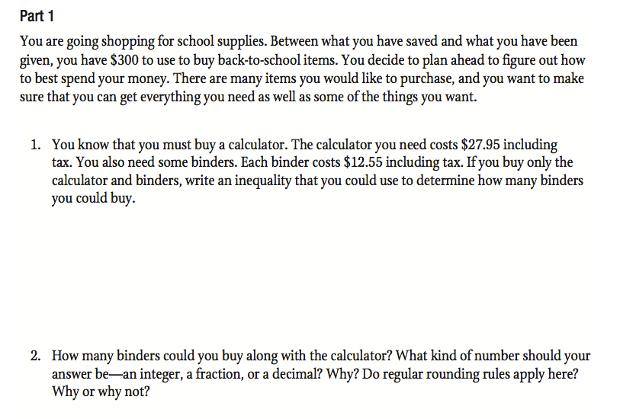

Name: _______________________________________

Date: __________________ Period: ________

