Name: _________________________________________

Date: _______________ Period: __________
Practicing Multiple Representations of Linear Functions
1) Mario’s plumbing service Charges $40 to make a house Call plus $25 an hour.
Equation:
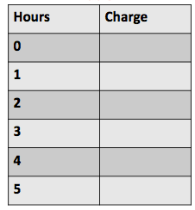

2) The cost of gas is $3.50 per gallon.
Equation:
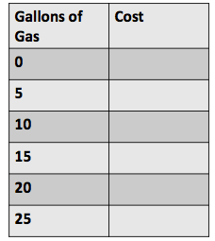

3) To convert from dollars to Euros, multiply dollars by 1.20
Equation:
US Dollars | Euros
0
5
10
15
20
25

4) The tree in my yard was 8 feet tall when it was planted And it grows 1 foot each year.
Equation:
Year | Tree Height in Feet
0
2
4
10
16
20

Pumpkins | Weight in Pounds
0
5
10
15
20
25

5) Each pumpkin weighs
1 and 3/5 pounds.
Equation:

