Linear vs. Nonlinear Patterns
Name: ____________________________

Your grandmother is giving you the following two options for your birthday:

- She will put $10.00 into your bank account on the day of your birthday and then $5.00 each month afterwards.
OR
- She will put $1.00 into your bank account on the day of your birthday and then every month she will put enough in your account to double the total amount you have.

Make a prediction: Which option will mean more money for you?

OPTION #1
Fill in a Table!  Month Total Amount  0  1  2  3  4  5 | Graph It!  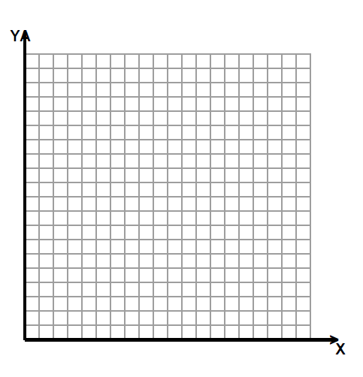 | Find the Function Rule!  (Use function notation.)

OPTION #2
Fill in a Table!  Month Total Amount  0  1  2  3  4  5 | Graph It! | Find the Function Rule!  (Use function notation.)
- How much money will be in your account in Month 6 for both options? How about month 10?

- At which point will the option #1 exceed $100? What about option #2?

- John says that for option 1 f(2)=20? Do you agree or disagree? Why or why not?

- Determine the domain and range for:

Option 1:
Option 2:

- How can we use graphs, tables, and function rules to help us make choices?

