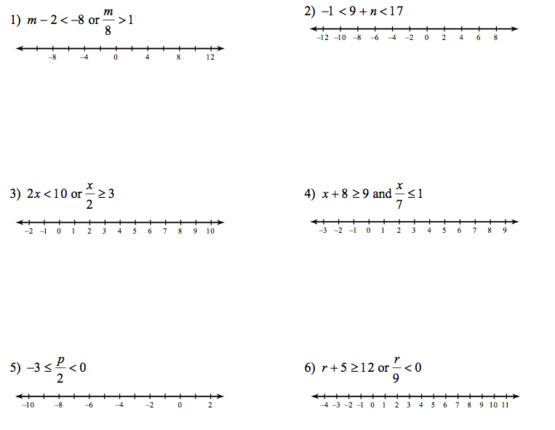

Name: ______________________

Date: _________

