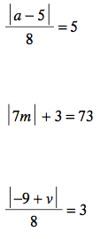
1)

3)

5)

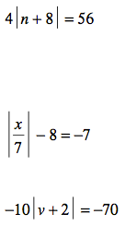
2)

4)

6)

7) A support beam for a building must be 3.5 meters long. It is acceptable for the beam to differ from the ideal length by 3 millimeters. Write and solve an absolute-value equation to find the minimum and maximum acceptable lengths for the beam.

8) A quality control inspector at a bolt factory examines random bolts that comes off the assembly line. Any bolt whose diameter differs by more than 0.04 mm from 6.5 mm is sent back. What is the maximum and minimum diameters of an acceptable bolt?

9) A machine prints posters and then trims them to the correct size. The equation L – 65.1 = 0.2 gives the maximum and minimum acceptable lengths for the posters in inches. Does a poster with a length of 64.8 inches fall within the acceptable range? Why or why not?

